Software Requirements Specification

Version 1

Point of Sale Management System

Team 6

|  |  |  |
| --- | --- | --- |
| **Member Name** | **Member Roll #** | **Primary Responsibility** |
| Ali Imran | 15L-4148 | Back-End Programming |
| Farhan Shoukat | 15L-4292 | Back-End Programming |
| Kamal Subhani | 15L-4048 | Database Programming |
| Hassan Alvi | 15L-4203 | Database Programming |
| Abdullah Asad | 15L-4063 | User Interface Development |

**Table of Contents**

1. Introduction 5

1.1 Product 5

1.2 Scope 5

1.3 Business Goals 5

1.4 Document Conventions 6

1.5 References 6

2. Overall Description 7

2.1 Product Features 7

2.1.1 Administrator Features 7

2.1.2 Manager Features 8

2.1.3 Sales Person Features 9

2.2 User Classes and Characteristics 9

2.2.1 Admin 10

2.2.2 Manager 10

2.2.3 Salesperson 10

2.3 Operating Environment 11

2.3.1 Hardware 11

2.3.2 Software 11

2.4 Design and Implementation Constraints 11

2.5 Assumptions and Dependencies 12

3. Functional Requirements 13

3.1 Login 13

3.2 Change Password 14

3.3 Order Print 15

3.4 Update Details of Person 16

3.5 Approval of Changes in Product 16

3.6 Approval of Changes in Person 17

3.7 Change Inventory Item Details 18

3.8 Search the Person 18

3.9 View Information of the Person 19

3.10 Search Information of Product 20

3.11 View Monthly/Yearly Sales 20

3.12 View Information of Inventory Items 21

3.13 Delete Item Details 22

3.14 Delete Person Details 22

3.15 Remove User Access 23

3.16 Addition of Inventory Item 24

3.17 Addition of Person 25

4. Nonfunctional Requirements 26

4.1 Performance Requirements 26

4.2 Security Requirements 26

5. Other Requirements 27

5.1 Software Requirements 27

5.2 Hardware Requirements 27

Appendix A: Glossary 28

Appendix B: Analysis Models 29

Appendix C: Design Models 34

**Revision History**

|  |  |  |  |
| --- | --- | --- | --- |
| **Name(s)** | **Date** | **Reason(s) For Change(s)** | **Version** |
|  |  |  |  |
|  |  |  |  |

# Introduction

## Product

**Point of Sale Management System** includes the hardware and software used in tandem to place orders, track sales, manage inventory and track revenue and profits. However, our product is only software based and is simply a POS desktop application designed to ensure a smooth transaction process between the retailer and the customer. Moreover, it will also effectively store all customers and sales data for further analysis like visualizing sales data or optimize pricing and also to check the sales trends of various products. These kind of applications are mainly used in small businesses such as departmental stores or supermarkets but they can be an efficient solution for most of the companies that maintain data in some specific sequence and require information regarding sales management.

## Scope

The scope of the functionalities of this application revolves around the user i.e. the retailer in this case. Firstly, the user would have to login in order to gain access. After a successful login, the main interface will show where the user in given the option to provide customer and product details which adds them into the database. Moreover, the user will be given the options to either add a new customer or a product and also to update product information. Sales person is restricted only towards taking orders, updating his password and registration of customers into the database. Manager would have the access to approve the entry of the person or the product as well as perform actions of the sales person. Admin has most of the rights where he/she can perform the functionalities which are pretty basic yet sensitive enough for anyone to alter except the administrator such as add, update and delete. The application focuses towards having numerous panels to access multiple features offline such as summary of sale records, manage products and person information, searching records saved in the past etc.

## Business Goals

This software will have huge impact on the business strategy of the client. The business goals which are expected to be achieved are listed below:

* Increased operating margins
* Quicker execution of company strategy
* Reduced employee turnover
* Establish a more effective and efficient goal-setting process
* Exponentially speed completion of company goals
* Boost employee cooperation company-wide with cascading goals
* Gain powerful insight by using collected data more effectively

## Document Conventions

Conventions followed within this document are:

* For Title: Arial font, 32 font size and bold font style was used
* For Headings: Times New Roman font, 18 font size and bold font style was used.
* For Subheadings: Times New Roman font, 14 font size and bold font style was used.
* For Paragraphs: Times New Roman font, 11 font size was used.
* For Main terms: Times New Roman font, 11 font size and bold font style was used.

All text are in justified alignment. Bullet points have also been used where a list of features or description was required. Images are attached in the Glossary B for further explanation of the system.

## References

|  |  |
| --- | --- |
| [1] | "freshworks," [Online]. Available: <https://www.freshworks.com/freshsales-crm/solutions/sales-management-system/>. |
| [2] | "INSIGHTSQUARED," [Online]. Available: <https://www.insightsquared.com/solutions/sales-management-system/>. |
| [3] | "Software Suggest," [Online]. Available: <https://www.softwaresuggest.com/blog/basic-features-sales-management-software/>. |
| [4] | "3G Vision," [Online]. Available: <https://www.3gbusiness.com.au/blog/amazing-features-of-any-sales-management-software/>. |
| [5] | "Research Gate," [Online]. Available: <https://www.researchgate.net/publication/307854899_Design_and_Development_of_a_Sales_Management_System_for_SMEs_in_Northern_Ghana>. |

# Overall Description

## Product Features

### Administrator Features

1. POSS will allow the admin to login.
   1. System will allow the admin to login using his username and password.
   2. System will prompt error message if admin provides wrong information.
2. POSS will allow the admin to add a person.
   1. System will allow the admin to add customer by entering admin details such as name, mobile number etc.
   2. System will prompt error message if admin provides wrong information.
3. POSS will allow the admin to add item to inventory.
   1. System will allow the admin to add a new product by entering name and price.
   2. System will prompt error message if admin provides wrong information.
4. POSS will allow the admin to print order.
   1. System will allow the admin to print bill upon clicking the print button.
   2. System will not allow admin to click on print button before the order is registered.
5. POSS will allow the admin to change password.
6. System will allow the admin to change password by provide old, new and confirm new password.
7. System will prompt error if the old password doesn’t match.
8. POSS will allow the admin to print order.
9. System will allow the admin to print bill upon clicking the print button.
10. System will not allow admin to click on print button before the order is registered.
11. POSS will allow the admin to update person.
12. System will allow the admin to update person details e.g name, address etc.
13. System will prompt error message if admin provides wrong information.
14. POSS will allow the admin to change details of items.
15. System will allow the admin to update the details of items residing in the inventory e.g name and price.
16. System will prompt error message if admin provides wrong information.
17. POSS will allow the admin to search for a person.
18. System will allow the admin to look for a person in the inventory using filters like mobile number.
19. System will prompt “No Entry” message if no user is found.
20. POSS will allow the admin view information of a person.
21. System will allow the admin to view people’s information in a tabular grid form.
22. POSS will allow the admin to search information of a product.
23. System will allow the admin search the product information like price.
24. System will prompt “No Entry” message if no user is found.
25. POSS will allow the admin to monthly and yearly basis sales.
26. POSS will allow the admin to view the information of the items that are residing in the inventory.
27. POSS will allow the admin to delete the details of the items.
28. POSS will allow the admin to delete the details of a person.
29. POSS will allow the admin to remove any user account.

### Manager Features

1. POSS will allow the manager to login.
2. System will allow the manager to login using his username and password.
3. System will prompt error message if manager provides wrong information.
4. POSS will allow the manager to change password.
5. System will allow the manager to change password by provide old, new and confirm new password.
6. System will prompt error if the old password doesn’t match.
7. POSS will allow the manager to print order.
8. System will allow the manager to print bill upon clicking the print button.
9. System will not allow manager to click on print button before the order is registered.
10. POSS will allow the manager to approve change in product.
11. System will allow the manager to approve the request of change in product.
12. System will remove products that are not approved.
13. POSS will allow the manager to approve change in person.
14. System will allow the manager to approve requests of change in person.
15. System will remove person that are not approved.
16. POSS will allow the manager view information of a person.
17. System will allow the user to view people’s information in a tabular grid form.
18. POSS will allow the manager to search information of a product.
19. System will allow the manager search the product information like price.
20. System will prompt “No Entry” message if no user is found.
21. POSS will allow the manager to view the information of the items that are residing in the inventory.

### Sales Person Features

1. POSS will allow the sales person to login.
2. System will allow the sales person to login using his username and password.
3. System will prompt error message if sales person provides wrong information.
4. POSS will allow the sales person to add item to inventory.
5. System will allow the sales person to add a new product by entering name and price.
6. System will prompt error message if sales person provides wrong information.
7. POSS will allow the sales person to change password.
8. System will allow the sales person to change password by provide old, new and confirm new password.
9. System will prompt error if the old password doesn’t match.
10. POSS will allow the sales person to print order.
11. System will allow the sales person to print bill upon clicking the print button.
12. System will not allow sales person to click on print button before the order is registered.
13. POSS will allow the sales person to search information of a product.
14. System will allow the sales person search the product information like price.
15. System will prompt “No Entry” message if no user is found.
16. POSS will allow the sales person to view the information of the items that are residing in the inventory.

## User Classes and Characteristics

There are three types of users in our system: Admin, Manager and Salesperson. The system usage will be divided in a hierarchy such that an Admin has the most authority and control over the system. Then comes the manager who has less control than the admin. And in the end is the sales person who is the day to day frequent user of the system.

### Admin

The admin will have the most authority and control over the system. Admin’s usage will be limited to only when a certain task needs to be done. The admin isn’t necessarily required to “stick” to the system all day. Technical expertise of Admin will be the highest among other users and he will be the most experienced. The minimum education requirement for an admin is Bachelor’s in a business management related field. He will also have complete access to the system from a security point of view.

The Admin’s main tasks involve the management of product inventory and user details. The system will allow the admin to login and add new users, edit user details, search for a particular user and to delete a user. The system shall also allow him to edit his own details such as password. These functionalities are highly sensitive and only accessible by Admin. Regarding product inventory, the system shall allow the Admin to have the privileges of adding and deleting products from the inventory. He will also be allowed by the system to search for a particular product in the inventory.

### Manager

Manager falls below the Admin in the usage hierarchy. The Manager needs to be available at the system together with the salesperson as he basically acts as a supervisor. Technical expertise of Managers involve the basic understanding of how the complete system works. Minimum requirement for being a manager is 14 years of education. The manager’s job is mainly to keep the flow of the system running by approving requests made by Admin and Salesperson.

The manager work is limited to approving the changes made to products and to manage the users. The system will allow the manager to login and approve product changes. He will also be allowed to approve the changes made to users. A manager will also be allowed by the system to edit and delete a user. The system shall also allow him to edit his own details such as the password.

### Salesperson

The salesperson falls in the lowest rank in the system usage hierarchy. A salesperson uses the system for the entire working hours. A salesperson needs to have knowledge of how to use a computer system and know its basic functions. A salesperson can be hired without any experience and be trained to use the specific system. Minimum education requirement for a salesperson is to be a high school graduate. A salesperson will have very limited access to the system and will mainly work on the order taking process.

The salesperson has the least privileges among other users. The system shall allow the salesperson to take orders by entering order details and getting a printed receipt. Aside from that, the system shall also allow him to login and change his password.

## Operating Environment

The operating system that was used to run this software was Windows 10. Some dependencies for instance: Microsoft Report Viewer 2012, SQL Server Types and Microsoft Processing Object Model were also used for reporting purpose, database setup and bill designing respectively. Hardware and software that were used during the process of developing this application are:

### Hardware

* 1. Intel Core i5 (2.3 – 2.4 GHz)
  2. 4 GB RAM DDR3
  3. 1 TB Toshiba Hard drive

### Software

* 1. Microsoft SQL Server 2008 R2
  2. Microsoft Visual Studio Professional 2015

## Design and Implementation Constraints

Design and Implementation Limitations include the following:

1. **Hardware Limitations**

Hardware required to perform the development of this application includes:

* 2 GB RAM DDR3
* 3rd Generation
* Dual Core 1.9 GHz CPU.

1. **Tools**

The tools required to develop POSS will be:

* Microsoft Visual Studio (2010 or above)
* SQL Management Studio (2008 or above)

1. **Database Technology**

Database to be used is Microsoft SQL Server Express (2008 or above).

1. **Language Requirements**

Language to develop the system are:

* C#
* ASP.NET
* SQL

1. **Operating System**

System will successfully run on Windows 7 (minimum) and above versions.

1. **Security Considerations**

Security consideration includes:

* + The users will keep their passwords confidential.
  + Sensitive operations like add, update and delete in database will only be available to the administrator.
  + Encrypted passwords will be stored in the database
  + SQL Injection attack will be prevented by using parameterized queries instead of direct concatenation of variables.
  + Three-tier architecture is followed to add more security to the data layer.

## Assumptions and Dependencies

Following assumptions are being taken for the development and deployment of this software:

* A new version of SQL may arrive but will not be updated during the development of the application.
* Similarly, Visual Studio and Visual C# will also remain unchanged during the development.
* Newer versions of above mentioned software may be used in future updates but during the development phase they will remain unchanged.
* As windows 10 is in continuous development, the future version of windows may not support some components of this software. Therefore, the application will be developed for Windows 10 1809 (October Update).
* There should be at least one Admin type user for the software to work properly. Other types of users can be zero.

# Functional Requirements

## Login

|  |  |  |  |
| --- | --- | --- | --- |
| **Identifier** | | UC-1 | |
| **Purpose** | | User can log into the system. | |
| **Priority** | | High | |
| **Actors** | | Administrator, Manager and Salesperson | |
| **Pre-conditions** | | Application should be running. | |
| **Post-conditions** | | Note Orders page will open. | |
| **Typical Course of Action** | | | |
| **S#** | **Actor Action** | | **System Response** |
| **1** | Enters username | |  |
| **2** | Enters password | |  |
| **3** | Clicks “Submit” button | |  |
| **4** |  | | Checks username existence in the database |
| **5** |  | | Username found |
| **6** |  | | Matches user’s password from the database |
| **7** |  | | Password matched |
| **8** |  | | Go to the “Note Orders” screen |
| **Alternate Course of Action (User not found)** | | | |
| **S#** | **Actor Action** | | **System Response** |
| **6** |  | | Username not found |
| **7** |  | | Display error message: User not found. Please try again.” |
| **Alternate Course of Action (Password Mismatch)** | | | |
| **7** |  | | Password did not match |
| **8** |  | | Display error message: “Incorrect password. Please try again” |

**Table 1: UC-1**

## Change Password

|  |  |  |  |
| --- | --- | --- | --- |
| **Identifier** | | UC-2 | |
| **Purpose** | | User can change his/her own password. | |
| **Priority** | | Medium | |
| **Actors** | | Administrator, Manager and Salesperson | |
| **Pre-conditions** | | User must be logged in. | |
| **Post-conditions** | | Password will be changed. | |
| **Typical Course of Action** | | | |
| **S#** | **Actor Action** | | **System Response** |
| **1** | Enters username | |  |
| **2** | Enters old password | |  |
| **3** | Enters new password | |  |
| **4** | Enters confirm new password | |  |
| **5** | Clicks “Submit” button | |  |
| **6** |  | | Checks username in database |
| **7** |  | | Username found |
| **8** |  | | Matches old password from the database |
| **9** |  | | Old password matched |
| **10** |  | | New and confirm password compared |
| **11** |  | | Both new passwords match |
| **12** |  | | Updates password of the user |
| **Alternate Course of Action (User not found)** | | | |
| **S#** | **Actor Action** | | **System Response** |
| **7** |  | | Username not found |
| **8** |  | | Display error message: User not found. Please try again.” |
| **Alternate Course of Action (Old Password mismatch)** | | | |
| **9** |  | | Old password did not match |
| **10** |  | | Display error message: “Incorrect password. Please try again” |
| **Alternate Course of Action (New Passwords mismatch)** | | | |
| **10** |  | | Both of the new passwords did not match |
| **11** |  | | Display error message: “New password did not match the confirm new password. Please try again.” |

**Table 1: UC-2**

## Order Print

|  |  |  |  |
| --- | --- | --- | --- |
| **Identifier** | | UC-3 | |
| **Purpose** | | User can print the order once it has been registered into the database successfully. | |
| **Priority** | | High | |
| **Actors** | | Administrator, Manager and Salesperson | |
| **Pre-conditions** | | User must be logged in. Order should have been registered before. | |
| **Post-conditions** | | System will print the order. | |
| **Typical Course of Action** | | | |
| **S#** | **Actor Action** | | **System Response** |
| **1** | Clicks “Print Receipt” Button | |  |
| **2** |  | | Receives data from Order Details table |
| **3** |  | | Checks if the information is available in the database |
| **4** |  | | Arranges the data in receipt form |
| **5** |  | | Shows print preview |
| **6** | Clicks on “Print” button | |  |
| **7** |  | | Sends the receipt to printer |
| **Alternate Course of Action (Information** **not found)** | | | |
| **S#** | **Actor Action** | | **System Response** |
| **4** |  | | Prompts an error message |

**Table 1: UC-3**

## Update Details of Person

|  |  |  |  |
| --- | --- | --- | --- |
| **Identifier** | | UC-4 | |
| **Purpose** | | To change personal details of the person. | |
| **Priority** | | Medium | |
| **Actors** | | Administrator | |
| **Pre-conditions** | | User must be logged in. | |
| **Post-conditions** | | Person details will be updated. | |
| **Typical Course of Action** | | | |
| **S#** | **Actor Action** | | **System Response** |
| **1** | Searches for the person | |  |
| **2** |  | | Displays the details of the person |
| **3** | Changes any of the person details (name, address, location, phone number, mobile number) | |  |
| **4** | Clicks “Submit” button | |  |
| **5** |  | | Forward changes to Manager’s panel for approval |
| **6** |  | | Displays confirmation message |
| **Alternate Course of Action (Information not found)** | | | |
| **S#** | **Actor Action** | | **System Response** |
| **2** |  | | Information not found |
| **3** |  | | Displays error message |

**Table 1: UC-4**

## Approval of Changes in Product

|  |  |  |  |
| --- | --- | --- | --- |
| **Identifier** | | UC-5 | |
| **Purpose** | | To approve the changes in the product details made by the salesperson. | |
| **Priority** | | High | |
| **Actors** | | Manager | |
| **Pre-conditions** | | User must be logged in. There should be at least one product that needs to be approved. | |
| **Post-conditions** | | Product changes will be reflect on User Interface. | |
| **Typical Course of Action** | | | |
| **S#** | **Actor Action** | | **System Response** |
| **1** |  | | Displays the list of inventory items |
| **2** | Selects the item | |  |
| **3** | Clicks “Approve Product” button | |  |
| **4** |  | | Adds product details into the database |
| **5** |  | | Displays confirmation message |

**Table 1: UC-5**

## Approval of Changes in Person

|  |  |  |  |
| --- | --- | --- | --- |
| **Identifier** | | UC-6 | |
| **Purpose** | | To approve the changes in the person details made by the salesperson. | |
| **Priority** | | High | |
| **Actors** | | Manager | |
| **Pre-conditions** | | Application should be running. There should be at least one person who needs to be approved. | |
| **Post-conditions** | | Person changes will be reflect on User Interface. | |
| **Typical Course of Action** | | | |
| **S#** | **Actor Action** | | **System Response** |
| **2** |  | | Displays the list of all the people |
| **4** | Selects a person | |  |
| **5** | Clicks “Approve Person” button | |  |
| **6** |  | | Adds person details into the database |
| **7** |  | | Displays confirmation message |

**Table 1: UC-6**

## Change Inventory Item Details

|  |  |  |  |
| --- | --- | --- | --- |
| **Identifier** | | UC-7 | |
| **Purpose** | | User can update information of specific product. | |
| **Priority** | | Medium | |
| **Actors** | | Admin | |
| **Pre-conditions** | | User must be logged in. | |
| **Post-conditions** | | Item details editing will reflect on User Interface. | |
| **Typical Course of Action** | | | |
| **S#** | **Actor Action** | | **System Response** |
| **1** | Selects a product | |  |
| **2** |  | | Shows item details to user |
| **3** | Clicks on Edit button | |  |
| **4** |  | | Asks user to type in new values |
| **5** | Types in new values | |  |
| **6** | Clicks on submit button | |  |
| **7** |  | | Prompts a message: "Item updated" |
| **Alternate Course of Action 1 (No Product in Inventory)** | | | |
| **S#** | **Actor Action** | | **System Response** |
| **2** |  | | Prompt a message: "No item in inventory" |

**Table 1: UC-7**

## Search the Person

|  |  |  |  |
| --- | --- | --- | --- |
| **Identifier** | | UC-8 | |
| **Purpose** | | User can find a person in the database. | |
| **Priority** | | High | |
| **Actors** | | Admin, Manager | |
| **Pre-conditions** | | User is logged in. | |
| **Post-conditions** | | Person details will be shown. | |
| **Typical Course of Action** | | | |
| **S#** | **Actor Action** | | **System Response** |
| **1** | Enters user’s phone/mobile number | |  |
| **2** | Clicks on submit button | |  |
| **3** |  | | Displays all the person information |
| **Alternate Course of Action 1 (Unknown user phone number)** | | | |
| **S#** | **Actor Action** | | **System Response** |
| **3** |  | | Prompt a message: "Person not found" |
| **4** | Clicks on Ok button | |  |
| **5** |  | | Clears person phone number field |
| **Alternate Course of Action 2 (Null phone)** | | | |
| **3** |  | | Prompts a message: "Please enter person’s phone number" |

**Table 1: UC-8**

## View Information of the Person

|  |  |  |  |
| --- | --- | --- | --- |
| **Identifier** | | UC-9 | |
| **Purpose** | | User can view details of a person. | |
| **Priority** | | Medium | |
| **Actors** | | Admin, Manager | |
| **Pre-conditions** | | User is logged in. | |
| **Post-conditions** | | Every person’s information will be displayed. | |
| **Typical Course of Action** | | | |
| **S#** | **Actor Action** | | **System Response** |
| **1** | Clicks on “Person Information” tab | |  |
| **2** |  | | Displays Person Name, Address, Mobile Phone and Payment Method |
| **Alternate Course of Action 1 (No Person in Database)** | | | |
| **S#** | **Actor Action** | | **System Response** |
| **2** |  | | Prompt a message: "No person in the database" |

**Table 1: UC-9**

## Search Information of Product

|  |  |  |  |
| --- | --- | --- | --- |
| **Identifier** | | UC-10 | |
| **Purpose** | | User can find a product in the inventory. | |
| **Priority** | | High | |
| **Actors** | | Admin | |
| **Pre-conditions** | | User is logged in.  Product search page is open. | |
| **Post-conditions** | | Product information will be displayed. | |
| **Typical Course of Action** | | | |
| **S#** | **Actor Action** | | **System Response** |
| **1** | Enters the name of item | |  |
| **2** | Clicks on submit button | |  |
| **3** |  | | Displays product details |
| **Alternate Course of Action 1 (Invalid Product Name)** | | | |
| **S#** | **Actor Action** | | **System Response** |
| **3** |  | | Prompts a message: "Product not found" |
| **Alternate Course of Action 2 (Null product name)** | | | |
| **3** |  | | Prompts a message: "Please enter product name" |

**Table 1: UC-10**

## View Monthly/Yearly Sales

|  |  |  |  |
| --- | --- | --- | --- |
| **Identifier** | | UC-11 | |
| **Purpose** | | User can observe the statistics of all the sales | |
| **Priority** | | Medium | |
| **Actors** | | Admin, Manager | |
| **Pre-conditions** | | User is logged in.  Sales Information Page is open. | |
| **Post-conditions** | | None | |
| **Typical Course of Action** | | | |
| **S#** | **Actor Action** | | **System Response** |
| **1** | Clicks “Sales Summary” menu item | |  |
| **2** |  | | Display the total profit, total sales, total items sold, item names, quantities and month. |
| **Alternate Course of Action 1 (No Sales ever made)** | | | |
| **S#** | **Actor Action** | | **System Response** |
| **2** |  | | Prompt a message: "No sales have been made yet." |

**Table 1: UC-11**

## View Information of Inventory Items

|  |  |  |  |
| --- | --- | --- | --- |
| **Identifier** | | UC-12 | |
| **Purpose** | | User can view details related to product in inventory. | |
| **Priority** | | Medium | |
| **Actors** | | Admin, Manager | |
| **Pre-conditions** | | User is logged in.  Product Information Page is open | |
| **Post-conditions** | | All products will be displayed. | |
| **Typical Course of Action** | | | |
| **S#** | **Actor Action** | | **System Response** |
| **1** | Selects product name from the drop down menu. | |  |
| **2** |  | | Displays the total quantity ordered from the beginning, total cost, total profit, price of the product, quantity in stock. |
| **Alternate Course of Action 1 (No Product in Database)** | | | |
| **S#** | **Actor Action** | | **System Response** |
| **2** |  | | Prompt a message: "No product in the database" |

**Table 1: UC-12**

## Delete Item Details

|  |  |  |  |
| --- | --- | --- | --- |
| **Identifier** | | UC-13 | |
| **Purpose** | | Delete a specific product. | |
| **Priority** | | Medium | |
| **Actors** | | Administrator | |
| **Pre-conditions** | | Product information is currently open. | |
| **Post-conditions** | | Deletion will reflect on User Interface. | |
| **Typical Course of Action** | | | |
| **S#** | **Actor Action** | | **System Response** |
| **1** | Enters the product name | |  |
| **2** | Clicks the delete button | |  |
| **3** |  | | Asks for the confirmation |
| **4** | Clicks on yes button | |  |
| **5** |  | | Deletes the product |
| **Alternate Course of Action 1 (Invalid Product ID)** | | | |
| **S#** | **Actor Action** | | **System Response** |
| **2** |  | | Displays error message “No product found” |
| **Alternate Course of Action 2 (User clicks on “No”)** | | | |
| **4** | Click on No button | |  |
| **5** |  | | Clears the product name text field |

**Table 1: UC-13**

## Delete Person Details

|  |  |  |  |
| --- | --- | --- | --- |
| **Identifier** | | UC-14 | |
| **Purpose** | | Delete information of a person permanently. | |
| **Priority** | | Low | |
| **Actors** | | Administrator | |
| **Pre-conditions** | | User information is currently open. | |
| **Post-conditions** | | Deletion will reflect on User Interface. | |
| **Typical Course of Action** | | | |
| **S#** | **Actor Action** | | **System Response** |
| **1** | Enters the id of a person | |  |
| **2** | Clicks “Delete Person” button | |  |
| **3** |  | | Ask for confirmation |
| **4** | Clicks on yes button | |  |
| **5** |  | | Checks if the person’s session is active |
| **6** |  | | Deletes the information of the person |
| **Alternate Course of Action 1 (Invalid User ID)** | | | |
| **S#** | **Actor Action** | | **System Response** |
| **2** |  | | Display error message “No person found” |
| **3** |  | | Clear the id field |
| **Alternate Course of Action 2 (User clicks on “No”)** | | | |
| **4** | Clicks on no button | |  |
| **5** |  | | Clear the id field |

**Table 1: UC-14**

## Remove User Access

|  |  |  |  |
| --- | --- | --- | --- |
| **Identifier** | | UC-15 | |
| **Purpose** | | Deletes the username of a specific user so that he/she cannot login but the data remains within the database. | |
| **Priority** | | Low | |
| **Actors** | | Administrator | |
| **Pre-conditions** | | User information is currently open. | |
| **Post-conditions** | | Access of specific user will be blocked. | |
| **Typical Course of Action** | | | |
| **S#** | **Actor Action** | | **System Response** |
| **1** | Enters id of a user | |  |
| **2** | Selects delete username button | |  |
| **3** |  | | Asks for confirmation |
| **4** | Clicks on yes button | |  |
| **5** |  | | Checks if the person’s session is active |
| **6** |  | | Deletes the information of the person username only |
| **Alternate Course of Action 1 (Invalid User ID)** | | | |
| **S#** | **Actor Action** | | **System Response** |
| **2** |  | | Displays error message “No user found” |
| **3** |  | | Clears the user ID text field |
| **Alternate Course of Action 2 (User clicks on “No”)** | | | |
| **4** | Clicks on no button | |  |
| **5** |  | | Clears the id field |

**Table 1: UC-15**

## Addition of Inventory Item

|  |  |  |  |
| --- | --- | --- | --- |
| **Identifier** | | UC-16 | |
| **Purpose** | | Stores the new product within the database | |
| **Priority** | | High | |
| **Actors** | | Administrator | |
| **Pre-conditions** | | Admin is logged in. | |
| **Post-conditions** | | Product will be entered in the database. | |
| **Typical Course of Action** | | | |
| **S#** | **Actor Action** | | **System Response** |
| **1** | Enter product and its information | |  |
| **2** |  | | Searches the product to find redundancy |
| **3** |  | | Store product information |
| **4** |  | | Prompt a message of successful entry |
| **Alternate Course of Action 1 (Duplication)** | | | |
| **S#** | **Actor Action** | | **System Response** |
| **3** |  | | Prompt the user a failed duplication message |
| Back to 1 | | | |

**Table 1: UC-16**

## Addition of Person

|  |  |  |  |
| --- | --- | --- | --- |
| **Identifier** | | UC-17 | |
| **Purpose** | | Stores the new user inside the storage. | |
| **Priority** | | High | |
| **Actors** | | Administrator | |
| **Pre-conditions** | | Admin is logged in. | |
| **Post-conditions** | | Person will be added in the database. | |
| **Typical Course of Action** | | | |
| **S#** | **Actor Action** | | **System Response** |
| **1** | Enter person and its information | |  |
| **2** |  | | Searches the person to find redundancy |
| **3** |  | | Store person information |
| **4** |  | | Prompt a message of successful entry |
| **Alternate Course of Action 1(Redundancy)** | | | |
| **S#** | **Actor Action** | | **System Response** |
| **3** |  | | Prompt the user a failed duplication message |

**Table 1: UC-17**

# Nonfunctional Requirements

## Performance Requirements

Performance requirement of POSS include:

* A user friendly user interface will be provided so that the user finds it easy to navigate whatever he/she is searching for. This will be done by naming the buttons, tabs and fields. Compulsory fields will be highlighted. Input masked fields like mobile number field will have an underline indicating restricted number of digits that can be entered.
* Allowing user to press enter will move user from one textbox to another. This way it will be convenient for the user to swiftly shift to another area of typing without going through the hassle of selecting the textbox via mouse
* Using combo boxes, in places will help user in quickly selecting the specific option instead of typing the whole text. Combo box to select location and product will be provided for user to just select an option from the list given since there are limited amount of items and locations from which a user can select.
* User will be allowed to use hotkeys instead of clicking the buttons, for instance: f4 to submit, f2 to delete the product. Again, this will increase the speed of the selection of an object, providing performance benefits to the user by reducing his task execution time.

## Security Requirements

Security enhances can be made within the application through these techniques:

* Blacklisting of characters will be done so that the user cannot accidently type in unknown keywords for example: digits in name field, alphabets in mobile field etc. This will provide user the security that his wrong entry cannot cause problem within the system.
* Asterisks will be used in password field to hide the password while the user is typing.
* Dialog Boxes will be prompted if user commits an action that can seriously affect the system. This way user will be provided an alert before he/she commits a wrong action.
* Disabling the options that are not needed in a specific scenario will also secure application from being damaged. For example: if the user submits the order, the submit button will be disabled. Once the user clicks the clear whole screen button, the submit button will be enabled again. Since when the user has added the order into the database, he/she can accidently press the submit button twice (if it remains enabled) making two orders that are same which can cause an issue in sale details. This disabling of those buttons that are not needed in a scenario will prevent user from making mistakes.
* Undo and Redo buttons will be allow user to resort back to the previous state. This method follows the Golden Rule: ‘Permit Easy Reversal of Actions” which provide security to the user that his state can be recovered. For instance: a user places a faulty order, now there will be an option to undo to remove the last order made from the database which will allow user to recover previous state of database.

# Other Requirements

POSS requires the following specification:

## Software Requirements

* Windows 7,8 or 10
* Microsoft Visual Studio 2010 or onwards
* Microsoft SQL Server 2008 or onwards
* Microsoft SQL Management Studio R2 2008 or onwards
* Microsoft Report Viewer 2012

## Hardware Requirements

* RAM 2GB or more
* CPU 3rd Generation or more
* Processor Dual Core 1.9 GHz or more

# Appendix A: Glossary

***POSS:*** *POINT OF SALE SYSTEM*

***Blacklisting:*** *Not allow certain characters to be pressed via keyboard.*

***Execution Time:*** *Time taken for the user to perform a certain task.*

***Hotkeys:*** *Special shortcut keys that are used to perform specific actions.*

***Turnover:*** *Rate at which the employees leave or join any company or organization.*

# Appendix B: Analysis Models

1. **ER DIAGRAM**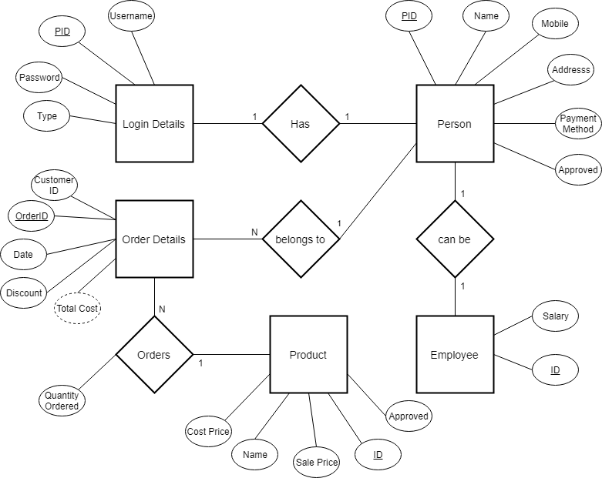
2. **USE-CASE DIAGRAM**

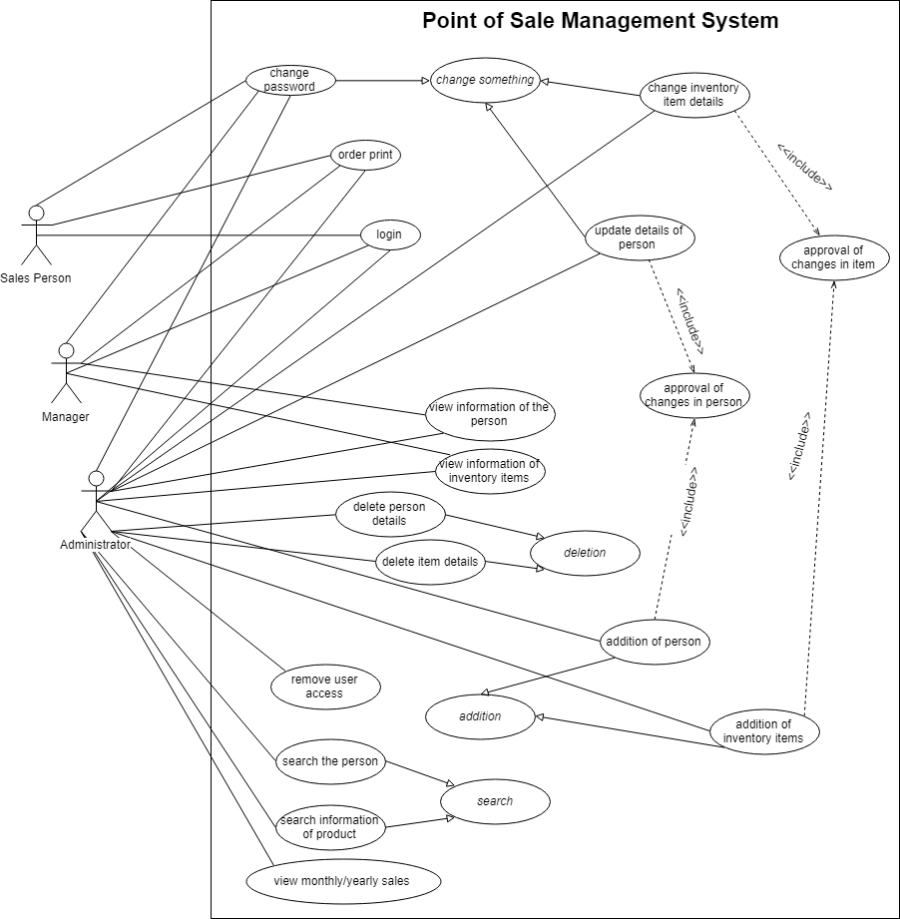

1. **CLASS DIAGRAM**

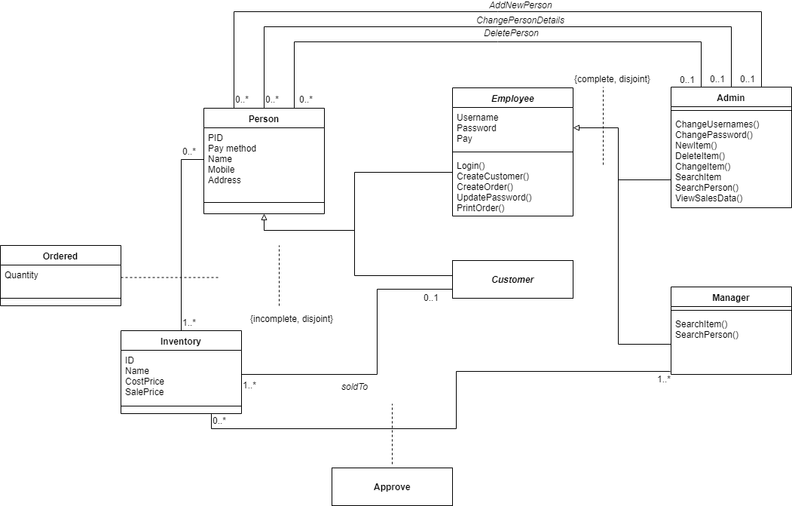

1. **DFD DIAGRAM**

* **Level 0**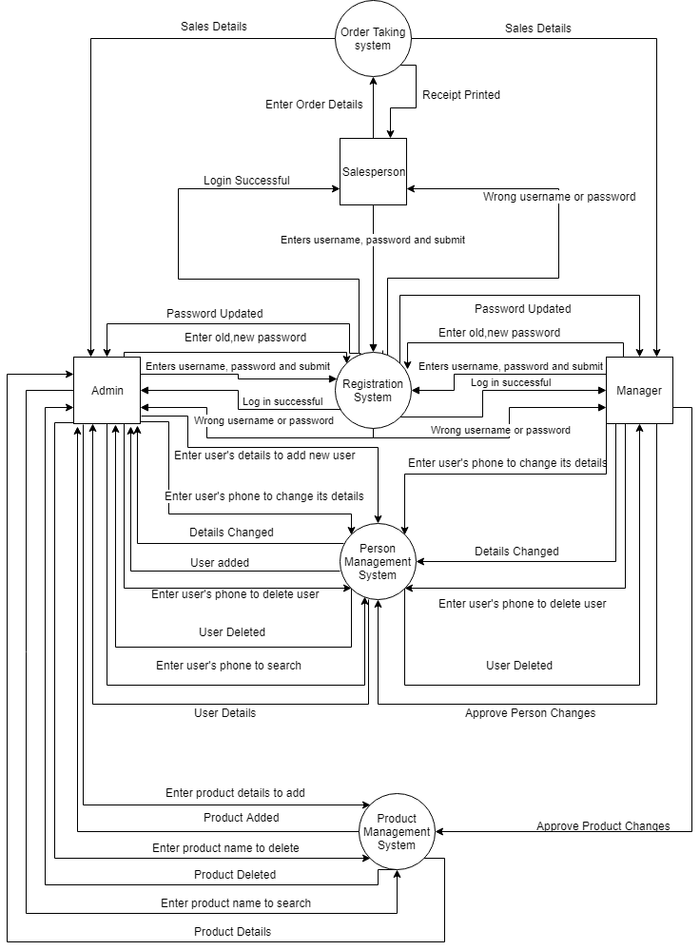
* **Level 1  
  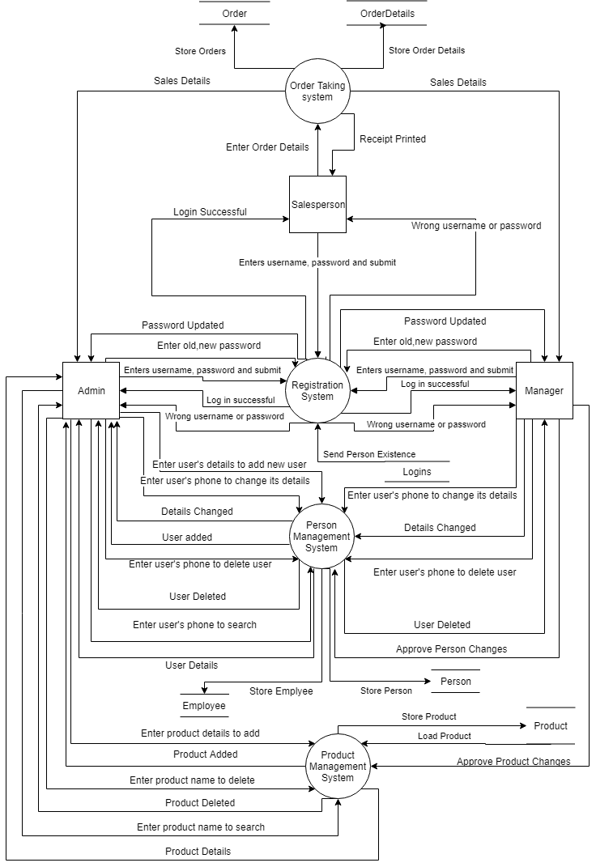**

# Appendix C: Design Models

1. 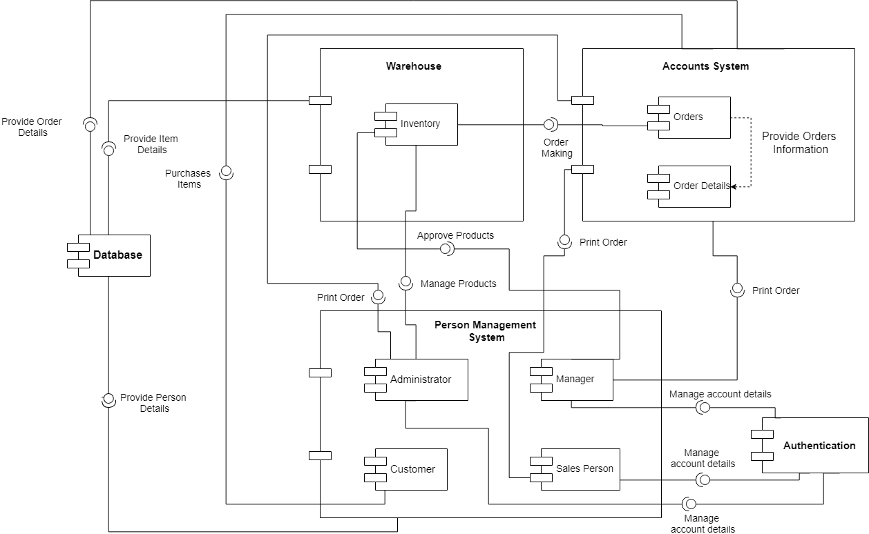**Component Diagram**